A Parent’s Guide
To Writing Workshop
What is writing workshop?
Writing workshop is an instruction model that focuses on the strengths and needs of each individual writer. Teachers provide direct instruction on the writing process, craft, genre and mechanics. Students are given time and choice of what to write, and opportunities to share with audiences.
Components of Writing Workshop
Mini lesson:
The teacher teaches a whole class lesson on writer’s craft or conventions based on the needs of the students. Children’s literature is read and studied to learn what writer’s do.
Independent work time:
Students:
• write a variety of genres.
• practice in a writer’s notebook what they were just taught in the mini lesson.
• brainstorm, draft, revise, edit and publish pieces.
The teacher:
• conferences with students about what they are writing.
• provides instruction to small groups of students.
Sharing time:
Students share what they wrote and how they applied the day’s mini lesson. This may be done as a whole class or in small groups.
How will my child be assessed?
Writing workshop assessment is ongoing. The teacher will closely monitor your child’s writing progress through notes taken during conferencing and small group work. Rubrics will be used to assess your student’s writing process, as well as end products for each genre. Participation and the writer’s notebook may be assessed as well. 1-3 published pieces will be assessed each marking period.

Three Types of Writing
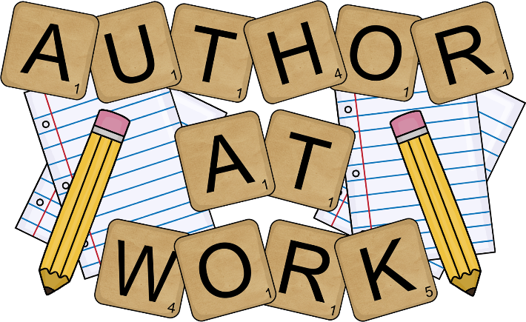
NARRATIVE WRITING
• tells a story
• can be real or imaginary
• has characters
• has a setting
• has a beginning, middle, and end
INFORMATIVE WRITING
• tells about a person, place, thing, event, or idea. • gives facts, details, examples, and/or explanations.
OPINION/ARGUMENTATIVE WRITING
• tells others what you think
• tries to convince others to agree with you by giving reasons, examples, facts, or details to support your opinion.

How to Help Your Child at Home
• Be a good model of writing. Let your child see you write and talk with him about how you use writing in your life.
• Help your child write letters and e-mails to relatives and friends.
• Provide a journal or diary for your child to record his or her day.
• Help your child brainstorm ideas and organize them.
• Stress the importance of the writing process and not just the final product.
• Respond to WHAT your child writes rather than HOW they write it.
• Praise your child’s writing. Ignore minor errors.
• Help with spelling as needed, but do not expect your child to spell every word correctly.

